Cangames 2016

presents

Cassandra and the Tesseract of Time

Katrina Ananova has lived the nightmare, and it is now. Without Tyrone’s strength, Galena’s intuition and Eric’s nature knowledge she and all her companions would surely be dead. The Abyss of Fire, Earth, Water and Air took all their combined skill to survive – and now, trapped in a bottomless cavern miles above the sub-oceanic volcano’s glow, she cannot see a way to escape.
But with Umberto Diaz there is always hope. Jane, as ever, will be sure to stumble forward into the next peril. A fourth monumental adventure in a land of ultimate danger—and less than half a reel of film left to capture the grittiest and most heart-pounding moments of all time. Poised on the brink of disaster, or the verge of unimaginable success, Umberto will see all their fates through to the end….

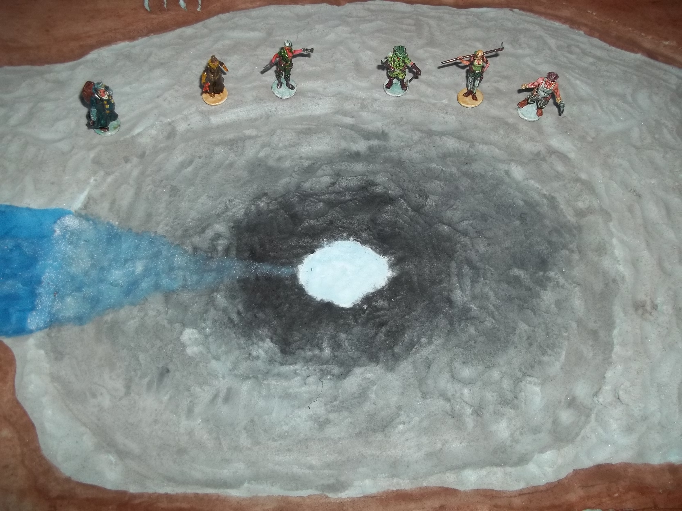

Can Cassandra Trimble Master Even the Twists of Time?

A Cavern of whistling, echoing fear surrounds Cassandra Trimble and her companions, having lurched upwards from the roaring fire of the Oceanic volcano, until their fragile balloon-boat crashed in this dark ominous place, miles above the volcano’s glow. No way back down, and eerie darkness all around. The doom of the planet hangs in the balance—the end of life as we know it. But how can Cassandra Trimble reshape the future, if she cannot escape the past?

AXIAL EVOLUTION PICTURES

Presents

CASSANDRA AND THE TESSERACT OF TIME

OR

Cassandra and the Children of Forever

Starring

Katarina Ananova as Cassandra Trimble
Tyrone Albertson as Alex Travers
Eric Van Daman as Roger de Groot
Galena Perez as Mona Gutierez

Written and Directed by the man who brought you Terror of the Deep, Cassandra and the Mountain of Doom, and Perils of Cassandra in the Lost World, and Cassandra and the Elemental Abyss…
Umberto Diaz

IN THEATERS DECEMBER 1939
Hollow Earth Expedition “Perils of Cassandra” – Cast of Characters

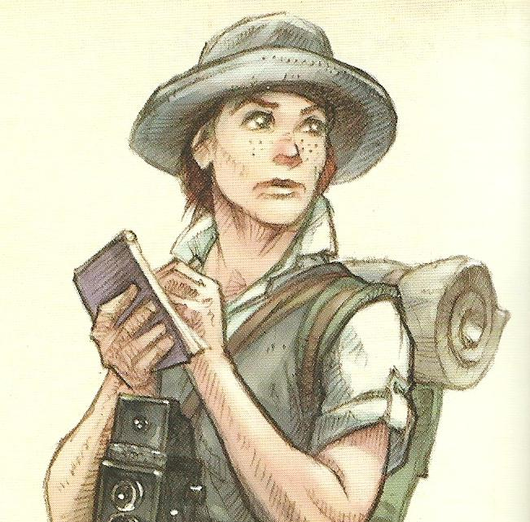
- Jane Evans (American, Texas) – Intrepid Reporter, always nosing around looking for a scoop, intent on a big story today as the latest picture starring Katrina Ananova takes live shooting to the danger zone.

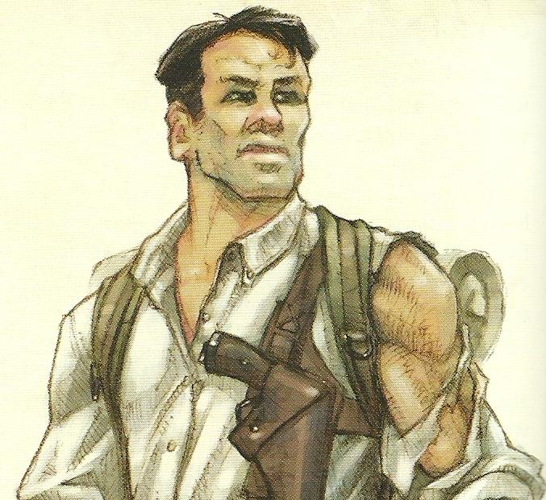
- Tyrone Albertson (Australian) – Rugged Explorer, turned movie star. Tyrone is a seasoned veteran of the wilderness, tough and unyielding, a wooden actor at best but with the looks needed for his role as Katrina’s guide on this perilous picture.

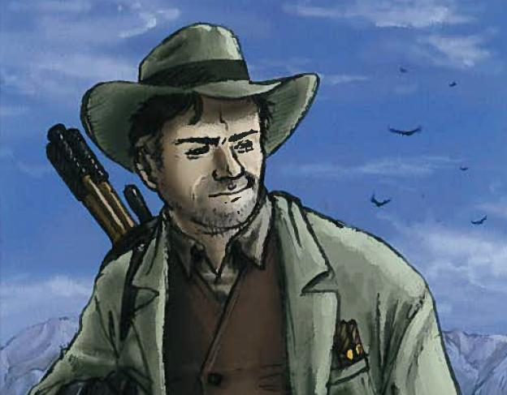
- Umberto Diaz (Portuguese) – Writer, Director, and part-time actor, Umberto likes to take his actors to the edge, put them in the real situation, and see what turns up in front of the camera. He is not a man easily persuaded, and has a knack for talking people into things.

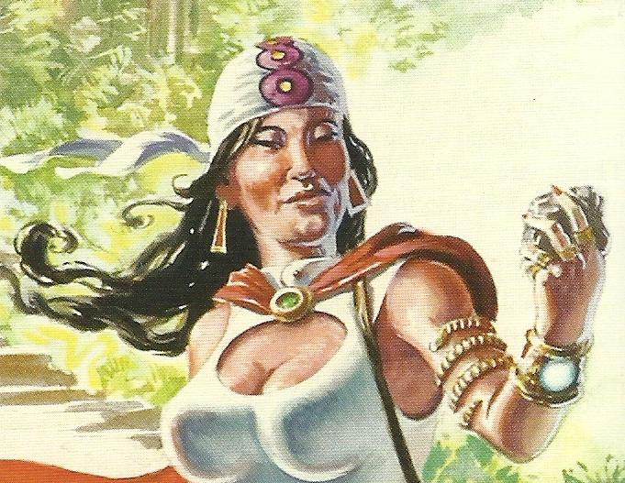
- Galena Perez (Mexican) – Occult Investigator, the mysterious supporting lady, who may be after Tyrone or may just be searching for some strange spirit that lives within the mountain. More dangerous than she looks, she also has an acute and eerie sensitivity for the bizarre and the mystical.

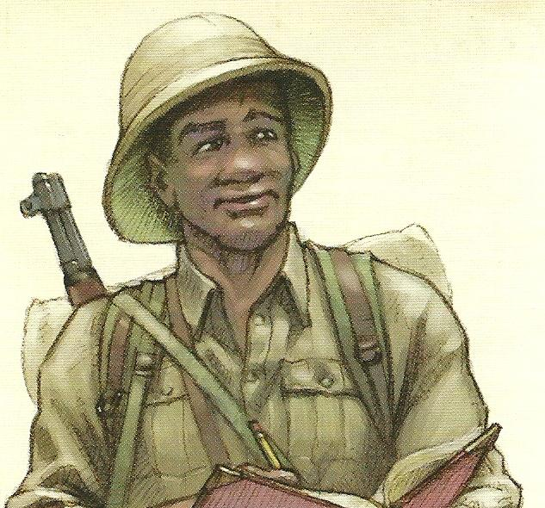
- Eric Van Daman (South African) – Field Biologist, a man entirely absorbed in the natural environment and its inhabitants, a reasonable actor who can hold his own in small character roles. As the supporting actor, he is usually sent in front whenever unknown animals appear, and Tyrone is fine with that – until there’s a fight.

- Katrina Ananova (Russian) – Imperiled Actress, Katrina can actually take care of herself better than she lets on, but she is so used to living her standard role of a damsel in distress that she almost believes it. Katrina’s female magnetism is only outweighed by her seemingly unerring ability to attract every kind of danger, which suits her role perfectly.

